Introduction
This is the ShopNest store PowerBI Capstone in which I have been provided with 9 datasets for business analysis through dashboarding.

Load & transform
Before starting I read about the business and its value chain operations. Then started with loading and transforming the datasets into Power query editor where I transformed the data by analyzing its quality through headers like data type & column header names.
I changed the first row to header in “product_category_name_translation” dataset from the transform tab.

Dashboard Design

Q1) Identify & visually represent the top 10 product categories by total sales.
Ans) For this I used clustered column chart with product category name at y-axis and sum of payment value at x-axis. Then I filtered the Top 10 items by payment values.
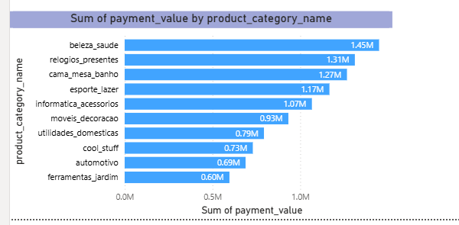

Q2) Determine the number of delayed orders.
Ans) Firstly, I cleared a calculated column and applied IF function to extract the delivery status. If delivered time is greater than estimated delivery time then it shows “Delay” otherwise “On-time”. Then I used CALCULATE () to create explicit measure to count the number of delayed orders. And then to visually represent the count I used “card”.
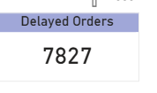

Q3) Create a dynamic visual that compare the number of delays orders to the number of on-time orders for each month.
Ans) Firstly, I created a new column of months from the estimated date column and for dynamic visual I used clustered column chart because it shows time-based (month) analysis efficiently.
- X-axis = months
- Y-axis = Count of delivery status (Delays/On-time)
- Legends = Delivery status
- Drill through = Delivery Status

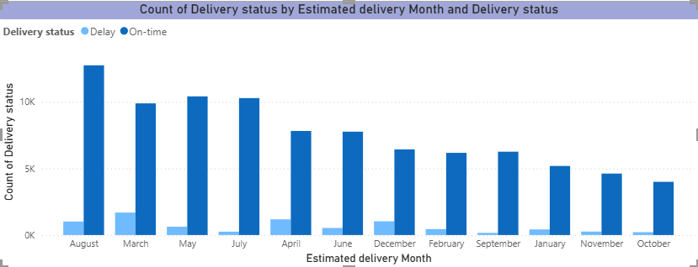

Q4) Analyze the most frequently used payment methods by customers.
Ans) Most frequently used payment method is Credit Card. I visualized it by using Pie Chart.
- Legends = Payment Type
- Value = Count of payment type
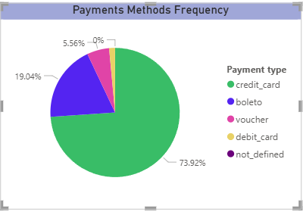

Q5) Determine the top 10 highest-rated products and bottom-10 lowest rated products.
Ans) I visualized the required analysis using clustered column chart. Which shows the trend over different product categories.
Bottom 10 categories are:
- Furniture Mattress
- Flowers
- Fashion Sport
- Diapers and hygiene
- Arts and craftmanship
- Home comfort
- CDs and DVDs musicals
- La Cuisine
- Fashion Children
- Security And services
Top 10 Categories
- Bed bath table
- Health beauty
- Sports leisure
- Computer accessories
- Furniture décor
- Housewares
- Watches gifts
- Telephony
- Toy
- Auto
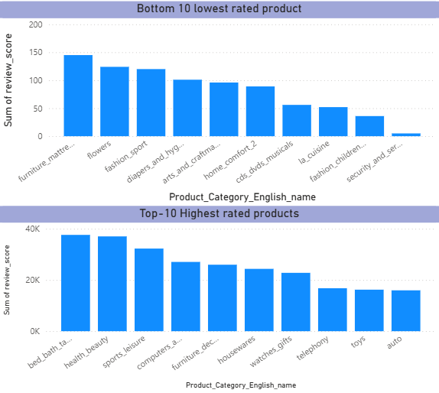
Q6) Identify and visually represent states with high and low sales, providing a clear understanding of regional sales performance.
Ans) To visually represent the state with highest and lowest sales I used multi-row card in which I put sum of payment value and average of payment. These two aggregations shows the full picture that state SP and RR experienced highest and lowest sales respectively.

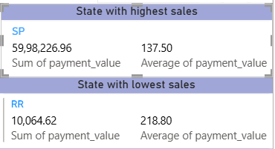

Q7) Investigate and visualize any seasonal pattern quarterly or trends in sales data over the course of the year.
Ans) Maximum payment value is seen in quarter 2 of 2018 and after that the sales started decreasing and became lowest in quarter 4 of 2018 this is because the number of orders is directly proportional to the sales i.e. if there is decrease in the order then sales also decrease and if there is increase in number of orders then sales is also decreasing.
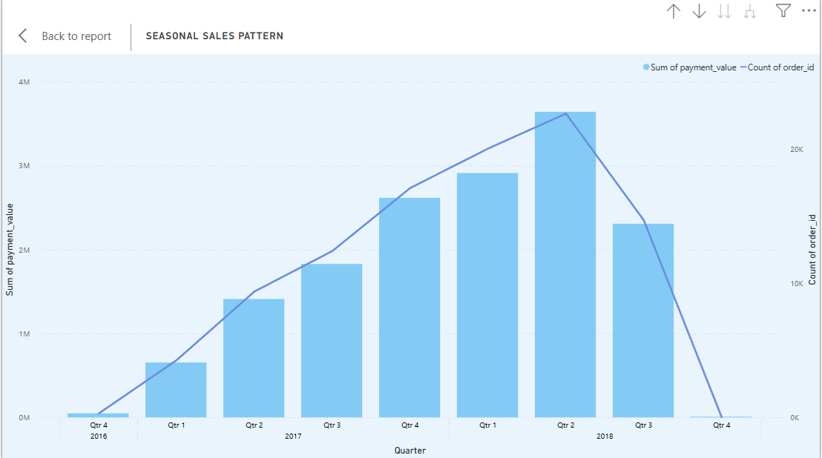

Q8) Determine the total revenue generated by ShopNest Store and analyze how it changes over time(yearly).
Ans) Total Sales of the ShopNest is 16.01 million & sales in 2018 is the highest for the store whereas in 2016 store experienced lowest sales

. 